Assaf Razin, March 30, 2004

A Colloquium on:
Economic Dimensions of a Permanent Agreement Between Israel and Palestine
I discuss potential domestic issues about the Palestinian economy, relevant for the “morning after”, when the two-state status will have been reached.

The expected INITIAL CONDITIONS of an emerging independent Palestinian Economy:
The World Bank estimates the loss of Gross National Income (GDP plus unilateral Transfers) at billions of dollars. The PA is effectively bankrupt with the collapse of tax revenues and donor countries contributions. WB: “Between September 2000 and December 2002, Real Gross National Income had shrunk by 38 percent from its 1999 level.” Unemployment stands now at more than 40 percent of the labor force. Investment is low at the hundreds of millions of dollars, rather than $ 1.5 billions in 1999. What are the theoretical possibilities of a recovery, if and when a Palestinian State will be established?

ARE THERE SOME HISTORICAL ANALOGIES FOR EMERGING INDEPENDENT ECONOMIES THAT WE CAN LEARN FROM?

I. Bosnia with Muslims, ethnic Serbs and Croats

Currently, Bosnia is a growing economy with a $6bn in foreign aid. Peace is sustained under the Dayton Accords, Signed in 1995, with 12,000 NATO troops, and formed the infrastructure for the recovery .

II. The Post WWII European Recovery: THE MARSHALL PLAN, launched at June 5, 1947 (Harvard University)

After two years of the Marshall plan industrial production in most of the area was above prewar levels.

In both episodes, (I) and (II), the emergence of a well-functioning market economy, and its sustained development, was based on radical, political and institutional, changes.
Two important institutional features were crucial (as in the writings of Andrei Shleifer and colleagues):
- Property-rights based institutional and legal structure;
- Restrictions on the power of the executive.

DISCUSSION:
An example of weak and strong institutional set ups: the Arab world vs. Asia, and Latin America and OECD Groups
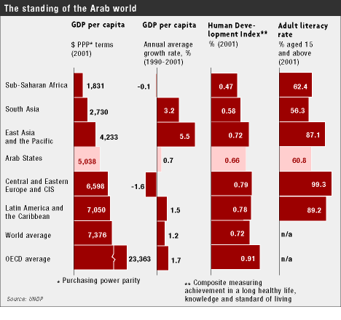
Restrictions on power of the executive? Not a single Arab leader has ever been peacefully ousted at the ballot box!
Property-rights based institutional and legal structure? The “Economist” (April 3rd, 2004, p. 41): “For the past 50 years, Arab states have devoted their energies to nation-building, an exercise that was seen to require political centralization, the forced mobilization of resources,…They often meant in practice the creation of bureaucracies that became giant patronage networks; the appropriation of oil revenues by the central government; the suppression of minorities; and the promotion of a cultuture of obedience through a controlled press and education system. At the same time the dramatically swelling population (the Arab league has grown from 157m to 280m, since 1980) and a flight from the country side to the towns have disoriented societies…”

II. The Palestinian Economy : Weak Institutions
Perhaps one reason for the Camp-David collapse is rooted in the absence of solid democratic institutions of government in the PA: the Autocracy/multiple armies/ corruption regime. A slow development of a property-right based institutional-legal infrastructure handicaps self- sustained liberalized economy, which could sustain itself totally independent of the Israeli economy.

The Palestinian society is becoming increasingly de-secularized. Growth would require liberalizing foreign trade, independent monetary authority, transparent fiscal system, etc. It becomes vulnerable to inflation, currency crises, banking crises, low investment in infrastructure, no industrial base, and more.

Liberalization requires radical changes in the institutions (government, financial, legal), and the secularization of the society, and democratization of political institutions.
Liberalization requires that people in government will surrender power, privilege, and access to bribery, all the benefits that they have acquired since 1993. Reforms require government with accountability and transparency.
Arafat was elected president of the PA in 1996. He has resisted any change in the system of patronage and corruption.\

III. Long-term Economic Difficulties for the would-be Palestinian Economy:
- Protectionism, which distorts international trade.
- Corruption, which is akin to a distortion tax: (a) unpredictable rates (b) taxing economic transactions. Any income generated from an economic activity is multiply taxed (unlike income tax or value-added taxation).
- Close relations between capital and government, leading to industry concentration, protectionism.
- shaky financial institutions, weakened by bailout guarantees , and capital market with vulnerabilities to financial crises.

IV. A Final Anecdote:
What are the expectations among Palestinians concerning the Independent Palestinian State?
I end my discussion with an anecdote:
I have recently witnessed a remarkable new construction boom whereby Palestinian villages turned into development towns.
The housing construction aim perhaps is to accommodate Palestinians, who are currently moving from the core areas of the West Bank into areas close to the expected border line. On its west side, which is expected (by these Palestinians themselves) to remain within Israel. In the morning after a two-state settlement will have been reached. For example the Arabic village Eissauie, near Mount Scopus. Apparently, the move reflects the Palestinians’ expectations as to what the benefits for them of a would-be Palestinian economy will be like. They want to be associated with the prosperous economy of Israel; for what it can offer them in terms of employment, health and education.

