Welcome to the Kassel dorms
Medicine students’ and advanced Medical Engineering students’ dorms
Haifa, 85 Alenbi st.
In this “welcome document” you will find necessary information for the dorms, along with a google map of the dorms’ surrounding area, tips on how to get to the hospitals and Faculty of Medicine, a few suggestions for restaurants and shopping malls and centres, as well as nearby markets for your necessities. As well as, tourism suggestions and internet websites for further entertainment and tourist sites.
For further assistance please contact Rahel,ASAR’s secretary at the Faculty, or either dorms’ coordinators –
Waseem Shehadeh at swasimsh@gmail.com , and in case of emergency - 0546625311
Offer Kotler at offer1988@gmail.com , and in case of emergency – 0526140662
The Dorms
At Entry Level
Upon arrival to the dorms, you will need to check in at the dorms’ superviser’s(Leonid’s) office, or at the guard’s desk(in case you arrive after 2 pm). Both , the office and the guard’s desk, are located at your left upon entering the dorms.
Either Leonid or the guard will check you in and give you a key to your dorm. Check out is done the same way.
- The laundry and dryers rooms are located at the entry level of the doorms, as well as the “game room”. For illustration, check the “Entry Level” map.
- Free wireless internet access at the Lobby.

Other Levels

At level 0 : Copy machine.
At level 1: A computer room(open 24\7) with internet access, and a gym (open only at specific hours during the week).
The Rooms
The rooms at the dorms vary. Some rooms are built for doubles, others for singles, but usually both have a joint bathroom and sink for 3-4 persons. The single rooms enclude a bed, a mattress, a desk, a chair, shelves, a refrigerator and an air conditioner. The doubles’ rooms enclude double of everything except for the refrigerator and the air conditioner. The rooms do not enclude a safe.
Internet access in the rooms – please ask for a free password when you chek-in.
What will you need to bring?
You will need to bring with you dishes, kitchenware, sheets, towels and soaps. In case you didn’t bring any, check the “Google Map” below for assistance. As well, we do not recommend you drink the tap water.
Google Map
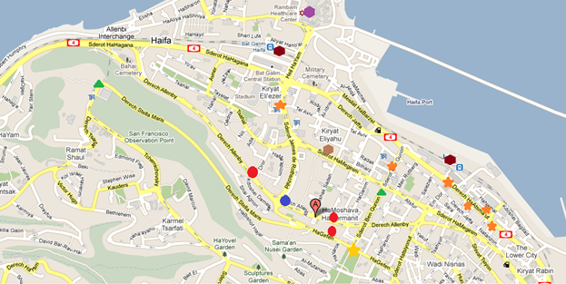
- Kassel dorms
Red circle – Minimarkets
Blue circle- Pizza&Pasta take out
Orange star – Shopping Mall\Centre\street
Golden star – Tourism Attraction – Bahae Gardens
Dark brown rectangular – Railway stations
Light brown rectangular – nearest Bus Station to reach Rambam,Carmel or Rocheld/Bnei Zion hospitals, as well as the Carmel Centre (restaurants, bars and a night-life centre)
Purple rectangular – Rambam Medical Centre and the Student Organization office.

Entry Level map
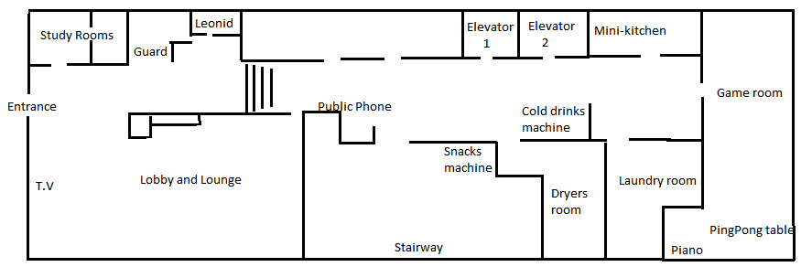
Usefull websites
- Railway website – rail.co.il\en
- Egged(bus company)website – egged.co.il\eng
- “Tour Haifa” website – tour-haifa.co.il\eng

