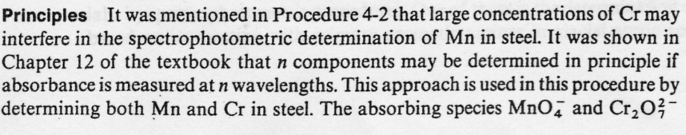
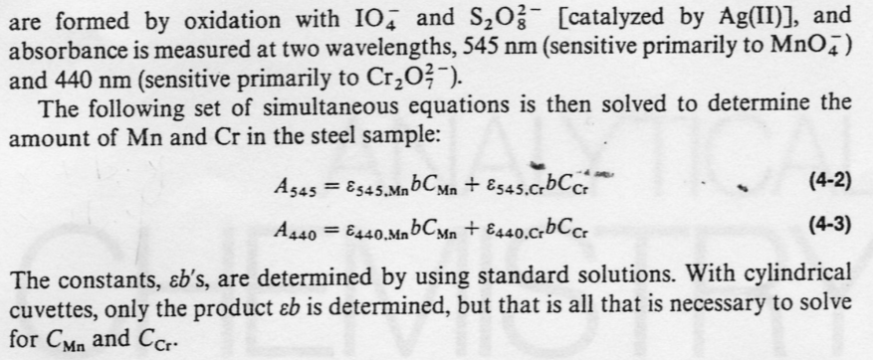
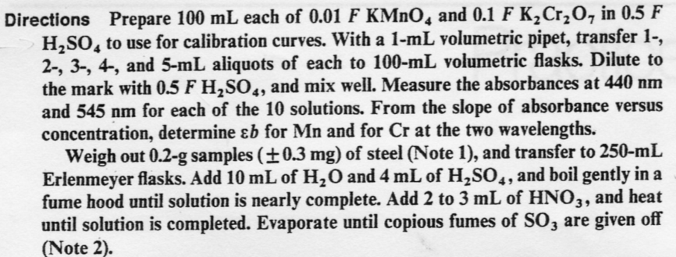
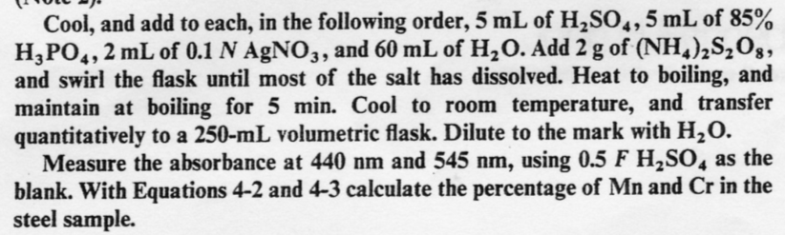
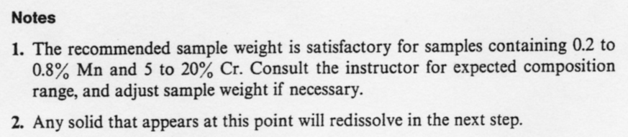

All procedures were taken from:

Analytical Chemistry, Practice, John H. Kennedy

