Determination of Mn in Steel

In the lab, you are going to determine the total amount of Mn and Cr in steel according to procedure 4.3. However, procedure 4.2 and its principles are very important and therefore it is recommended to read and understand it.
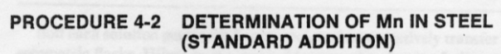
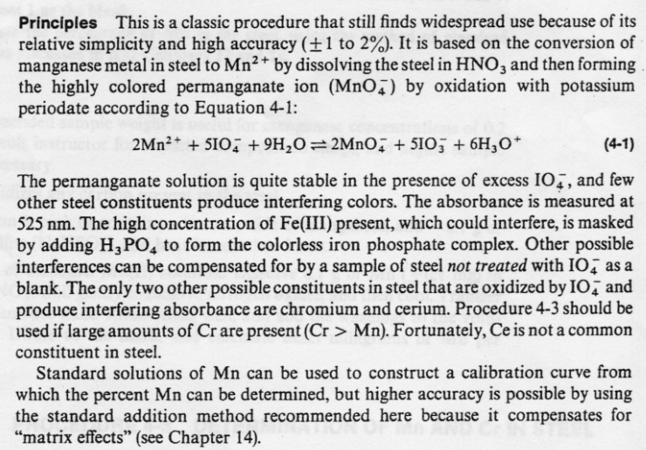
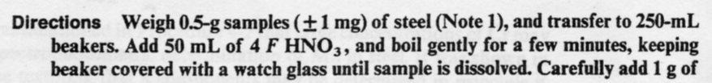
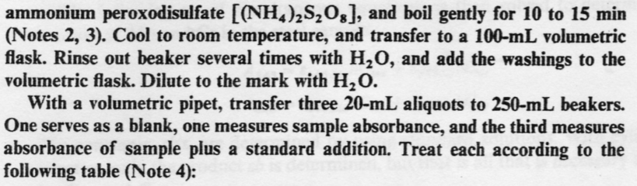
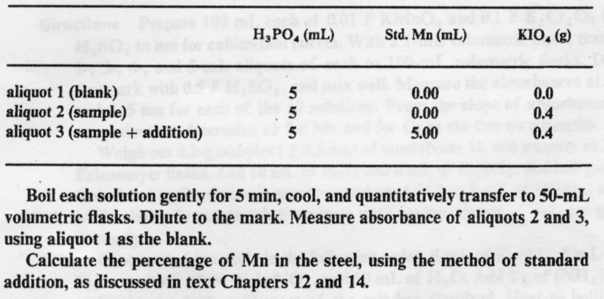
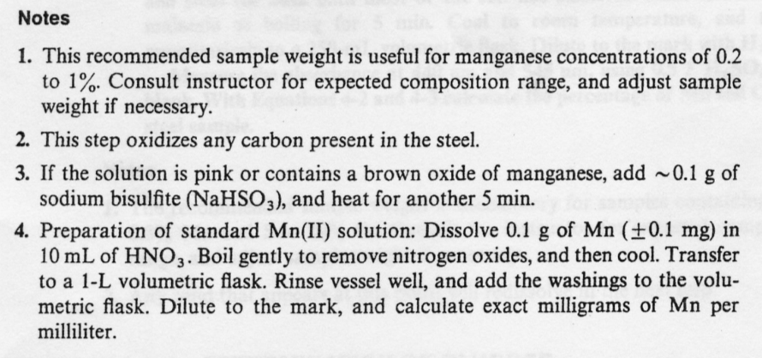

All procedures were taken from:

Analytical Chemistry, Practice, John H. Kennedy

