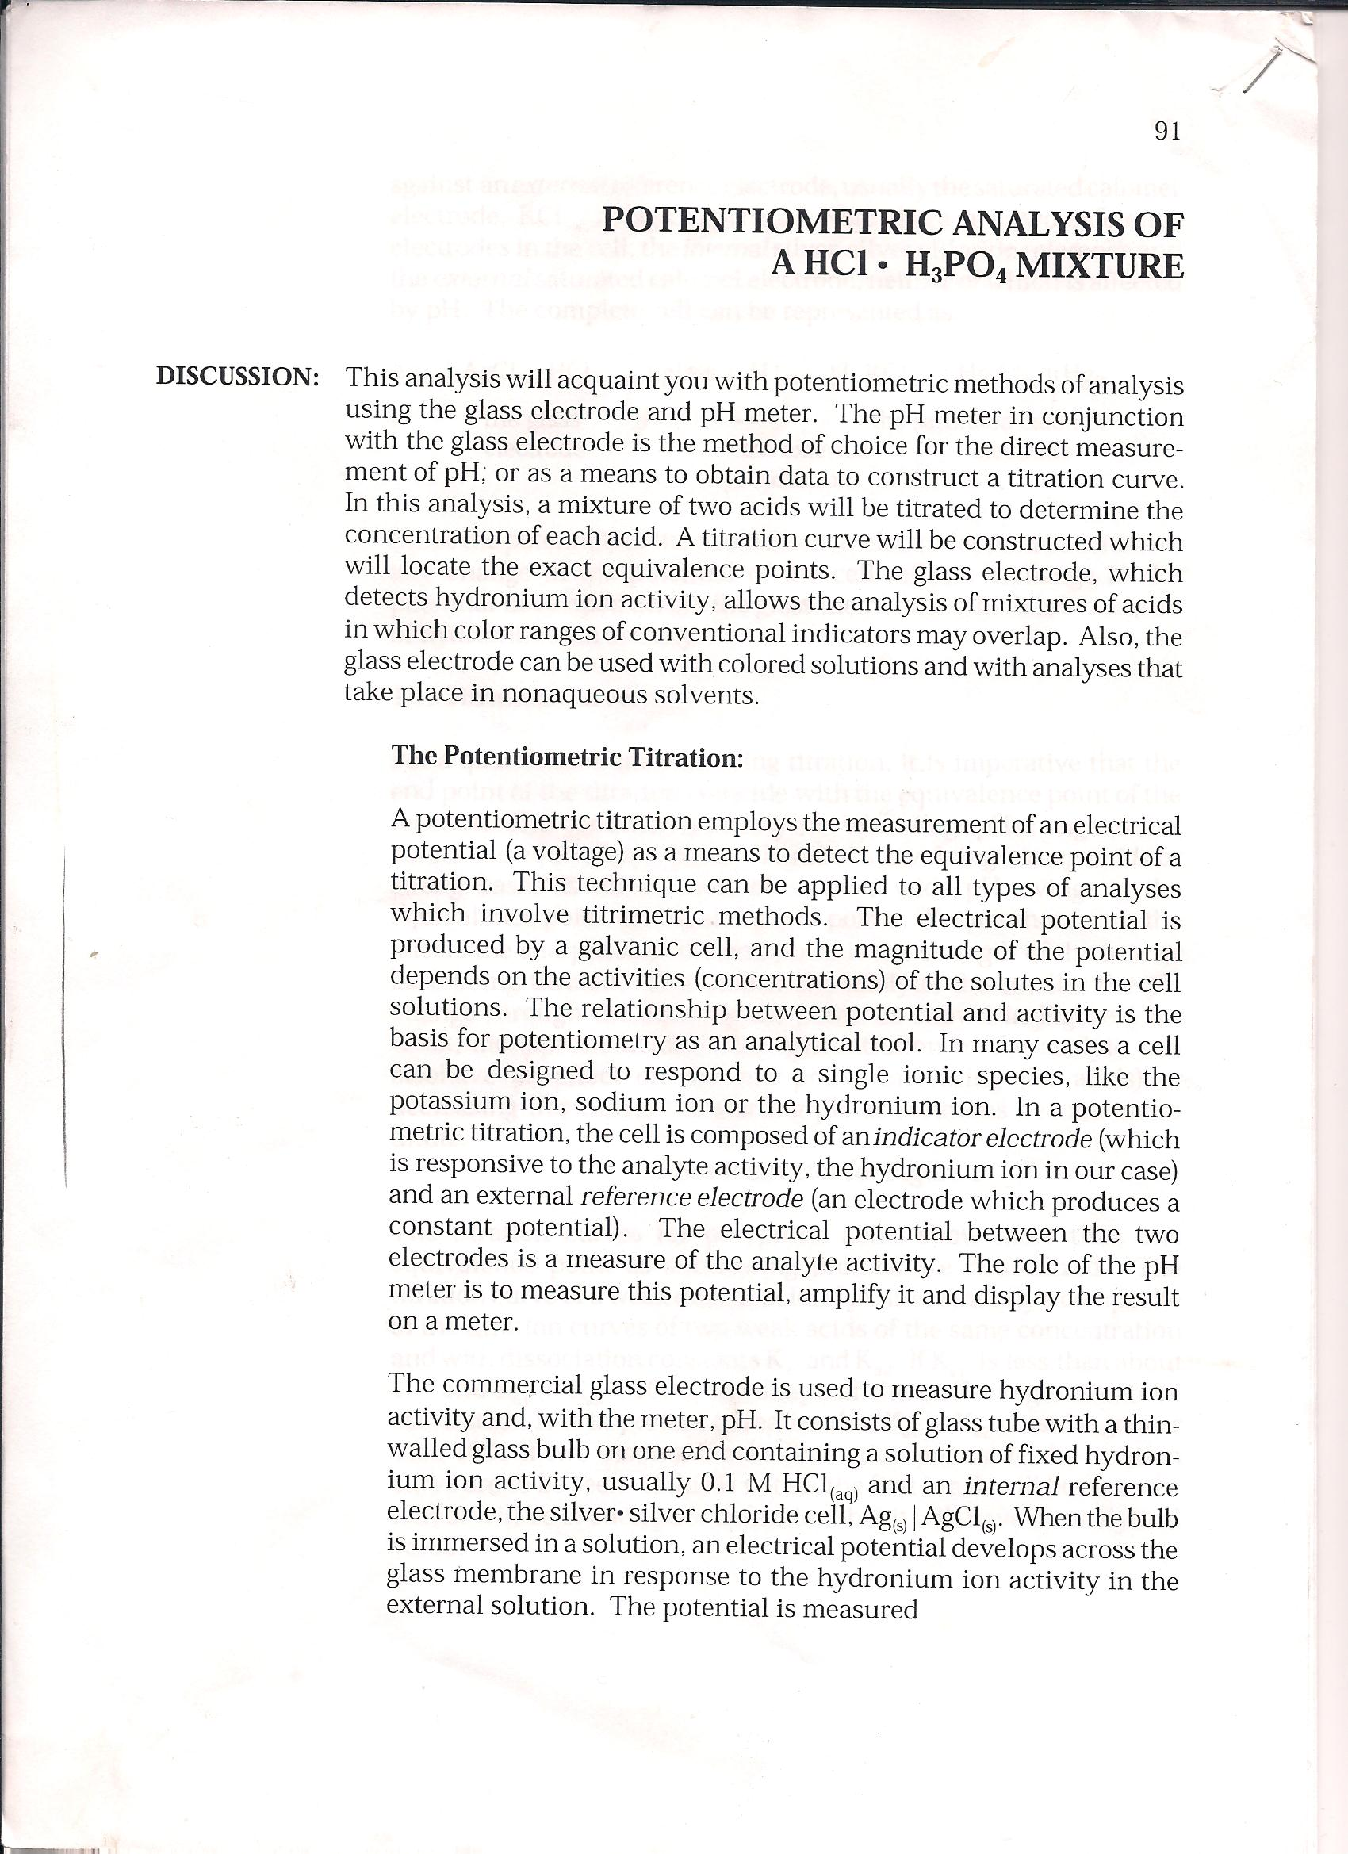

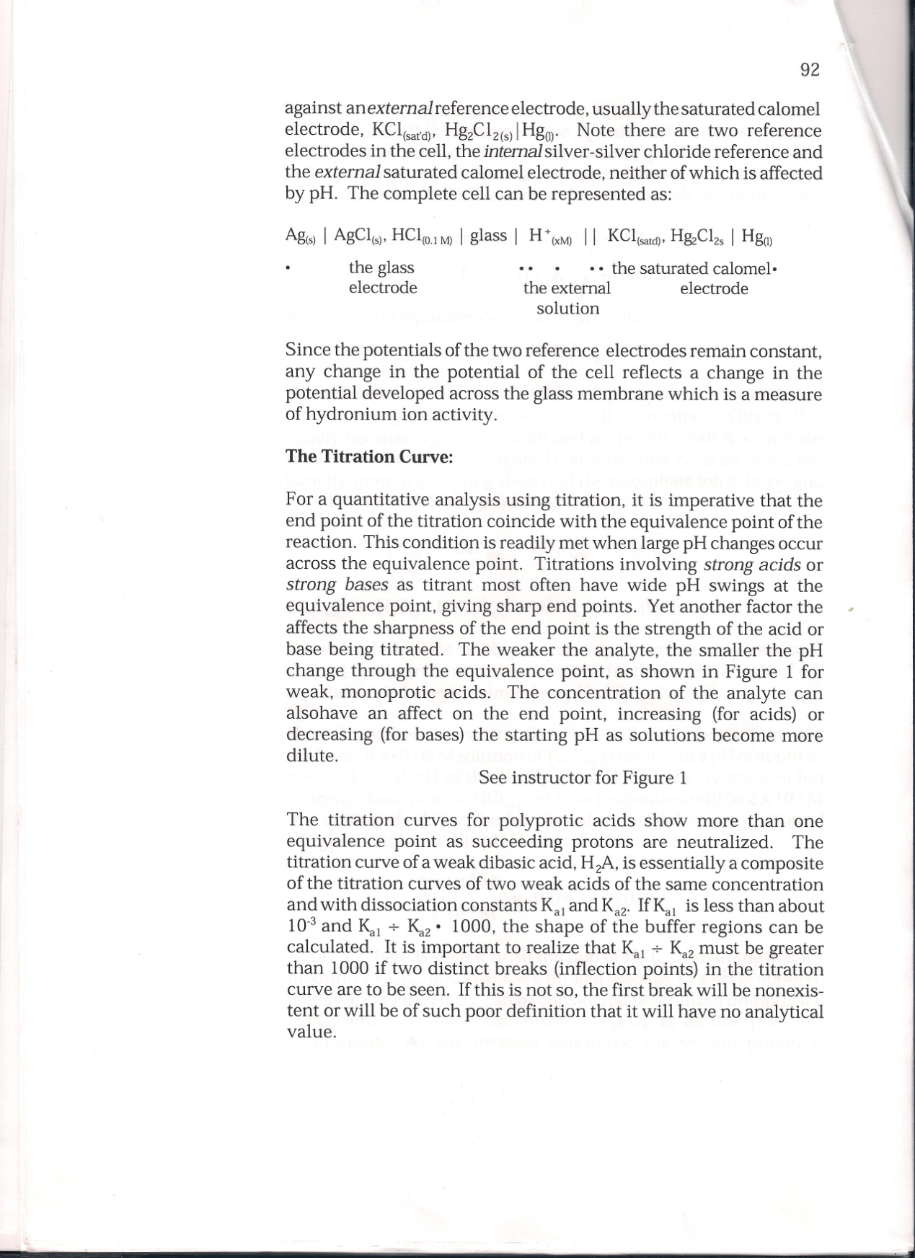

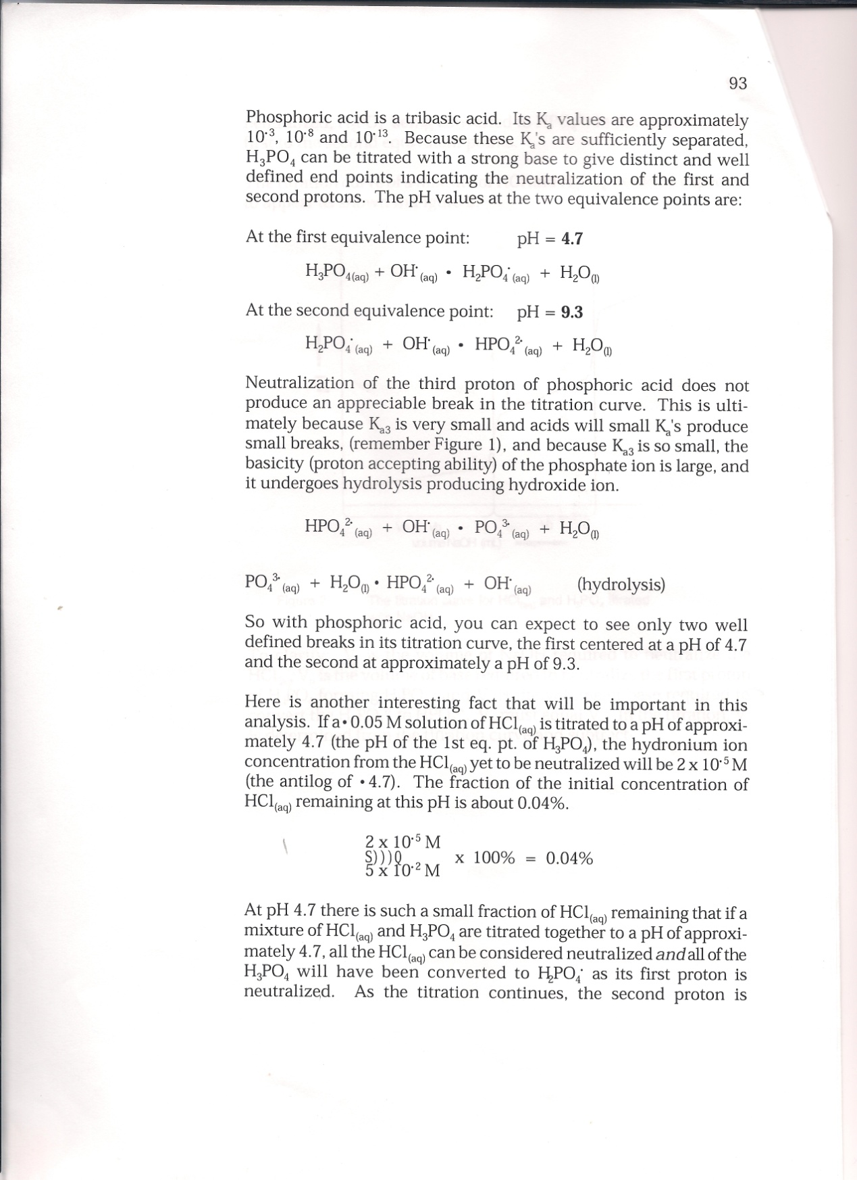

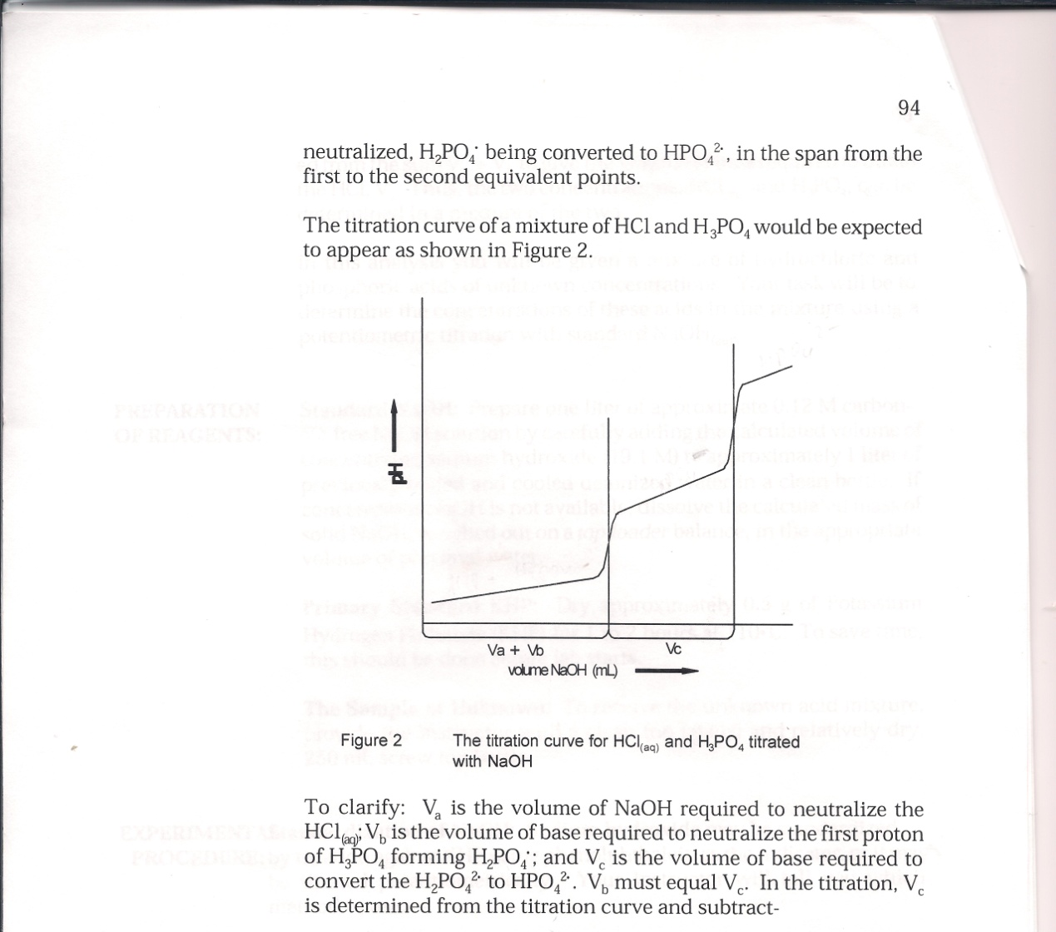
ed from the sum Va + Vb to give the volume of base required to titrate the HCl, Va. Thus, the two concentrations, HCl(aq) and H₃PO₄ can be determined in a mixture of the two.

