עבור: קרן נבון-קימל
מזכירות מרכז-על ע"ש שלזאק

RESEARCH REPORT - Dec 2017

Development of Deep Learning methods for the Representation and Modeling of 3D Heart Chambers, in particular the left Atrium, using CT, MRI, or electrode-based points during a Catheter ablation procedure

Please see 1 page Abstract below.
Work is now being summarized for submission to the IEEE-EMBC conference.

Cardiac arrhythmia is a group of clinical conditions in which the heart beat is irregular. Catheter ablation guided by electro-anatomic mapping (using CARTO or similar 3D mapping system) is one of the major invasive treatment choices for Cardiac arrhythmia. During such a procedure anatomical structure and electrical data is collected from many sensors mounted on the catheter (position, electrodes, ultrasound) or outside imaging modalities which require non rigid registration since the heart is not a rigid structure. See the figures below, on the left is the left atria chamber. On the right is the right atria while the points show places acquired by the catheter, the mesh represents a surface reconstruction of the anatomy and the color describe the electrical propagation time over the surface.
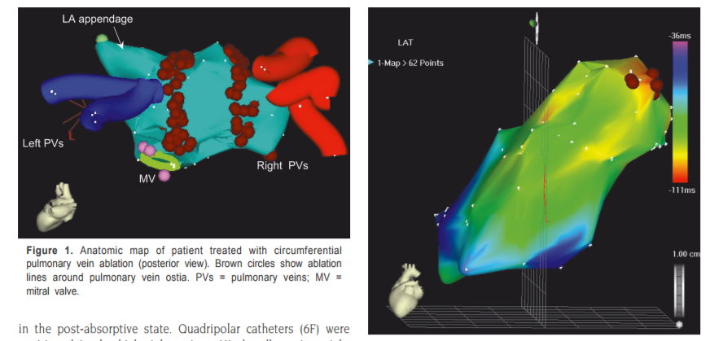
During the procedure and as early as possible, the physician expects to see a smooth anatomical surface with known anatomical parts and common proportions and orientations.

M. Suleiman et al Elc phys (2007)

In the research conducted in the past year, we developed a statistical model based approach via a neural network, to capture the requirements described above. We use unsupervised learning to model the geometry using de-noising autoencoders. We demonstrate their ability to capture and reconstruct the shape and geometry of 3D atria models using partial data. We introduced a spatial weight smoothing to learn smooth shape parts. We show the qualitative improvement in the result and the ability to learn deeper network with the same data.
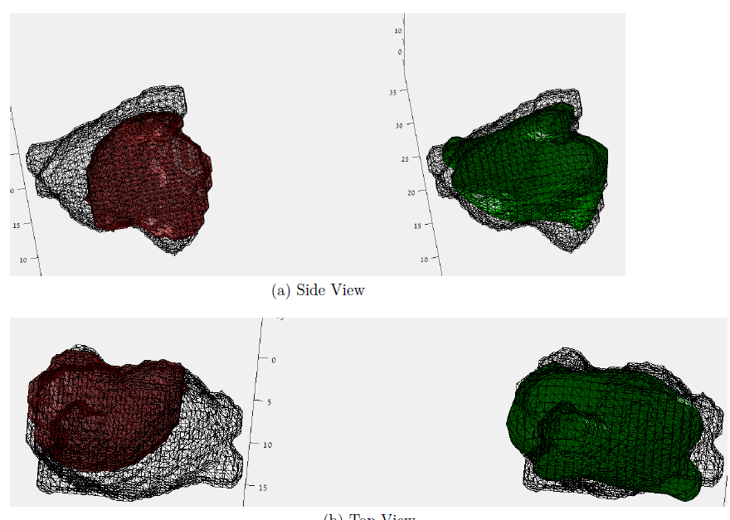
In our experiments we were able to demonstrate that the network can learn to complete the shape of the left atria in a scenario in which a sphere of radius 10mm that intersects the atria is visible (i.e. much data is missing). In the figure below we show the partial input to the network - red, and the reconstruction in green. The wireframe is the ground-truth. Top and bottom are side and top view, respectively.

