IN SITU MYOCARDIAL TISSUE ENGINEERING WITH NOVEL METHOD OF NON-THERMAL IRREVERSIBLE ELECTROPORATION
Shlezak 2012: Progress Report
Professor Jonathan Leor and Dr. Elad Maor
Brief description of the research subject: Our proposal aimed to develop in situ a cardiac decellularized tissue scaffold using non-thermal irreversible electroporation (IRE). The long-term goal is to use this scaffold to create new heart muscle, and to develop therapeutic approached for heart failure.
Methods: We used finite element simulation models to determine possible IRE protocols. Safety and efficacy of in-vivo IRE were evaluated with two needle electrodes in an open thoracotomy rodent model, comparing six different protocols. Degree of ablation was determined by histologic analysis at day 7. This experiment was followed by an in vivo experiment (N=24) which compared myocardial damage of three IRE intensities (500V, 250V and 50V) with that of a rodent model of myocardial infarction (MI). Animals were followed for 28 days. Echocardiographic evaluation was performed at days 0, 7 and 28. The extent of myocardial damage was determined by histologic analysis at 28 days.
Results: Computer simulation showed that 10 direct currents of 100 microsecond pulses at a frequency of 1 Hz do not induce a significant increase in temperature within a wide range of potential differences. In vivo IRE induced myocardial cell death within seconds, without significant arrhythmias or heart failure. Dysfunction of the myocardium was evident within minutes with the use of echocardiography. Histologic analysis showed that an IRE protocol of 500V induced a 60% reduction in myocardial thickness at day 7. Echocardiographic analysis at 7 and 28 days showed significant deterioration of ejection fraction and fractional shortening in the 500V and MI groups compared with 250V and 50V groups (P<0.05). Histologic analysis at 28 days showed that the percentage of scarred myocardium was 36%±18%, 11%±10%, 8%±6% and 3%±4% in the MI, 500V, 250V and 50V groups, respectively. Figure 1 shows decellularized myocardial tissue following IRE. Figure 2 shows changes in scar width following MI and IRE. Figure 3 shows deterioration of ejection fraction at 7 and 28 days following IRE and MI.
Conclusion: Our preliminary results describe for the first time an irreversible electroporation protocol that selectively ablates cellular components in the beating heart with no thermal damage. This modality can be used as a novel tool for myocardial tissue ablation in order to generate natural scaffolds for myocardial tissue engineering.
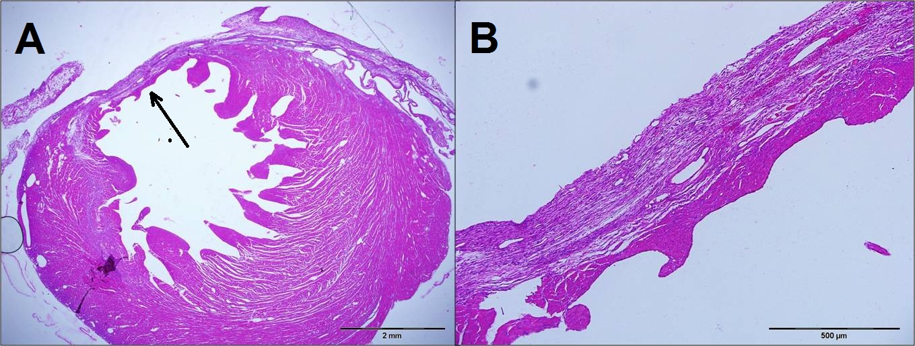
Figure 1: The figure shows the effect of myocardial ablation using irreversible electroporation after 7 days. Both images are pathologic specimens of the left ventricle with standard H&E. Left Image (A) shows X2 magnification with the arrow marking the area of maximal myocardial damage. Right image (B) shows larger (X10) magnification of the same specimen.

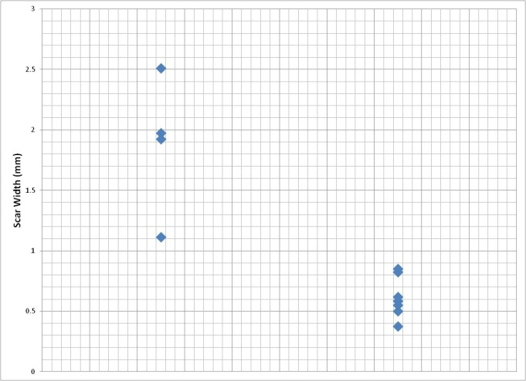
Figure 2: The figure shows changes in scar width 28 days after intervention, and compared control group of myocardial infarction (left) and IRE group (right). The figure shows that the scar width of IRE treated myocardium is thinner (p <0.01).
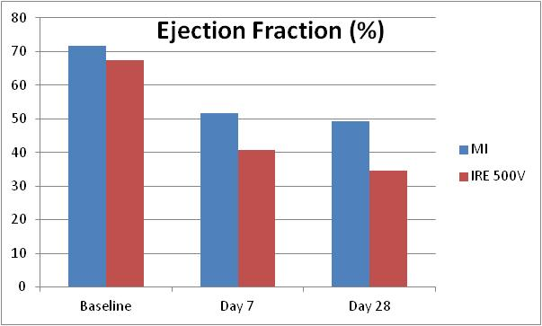
Figure 3: The figure shows changes in left ventricular ejection fraction at baseline, and at 7 and 28 days post intervention. The figure shows significant deterioration in the function of the left ventricle in the IRE-treated heart compared with standard myocardial infarction model

