Effect of 16 Hz magnetic field on KATP channel current and action potential in isolated cardiac myocyes and in a numerical model.
Mickey Scheinowitz and Sharon Zlochiver
We investigated the topographic characteristics of low frequency pulsed electromagnetic field generated by different geometries of coil design. For that purpose we used CST Studio Suite 2012 computer simulation program. Different coil shapes were analyzed such as "coil", "spiral", and "rectangle" and the magnetic field on X, Y, and Z axis, at different distances were determined (see figure).
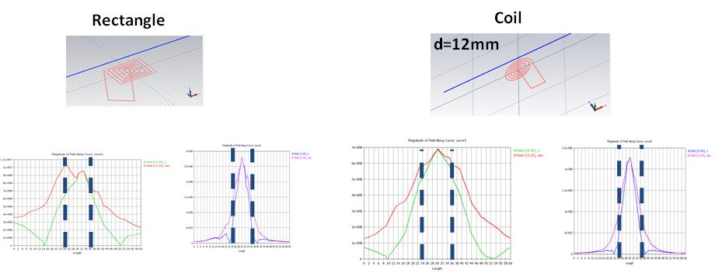
Coil shape demonstrated bell-shape magnetic field at 20 mm away from the coil, while the rectangle shape demonstrated more horizontal line at the same distance. However, when several coils were connected together, the distance from the coil was important; 20 mm away from the coil generated smooth magnetic strength along the 3 coils which was completely uneven at 5 mm (see figure).

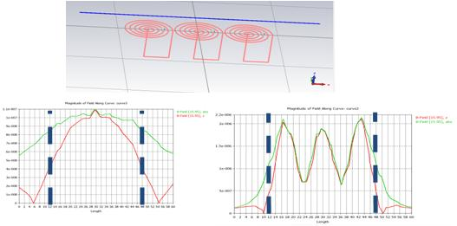
From the current data it is concluded that spiral design generates homogenous magnetic field at a given distance from the coil; in other words, if the coil will be positioned on the human body, it will produce an equivalent effect in the deep layer of the body. These data would also serve the numerical model which is necessary to understand the biological effect of magnetic-tissue interaction.

