December 2011 - Annual Report
Non-invasive Fractional Flow Reserve (FFR) using 3D-QCA and computational fluid dynamics (CFD) for assessment of functional significance of coronary lesions
Prof. Ran Kornowski, Interventional Cardiology, Rabin Medical Center

Phase I – Experimental model

Introduction:
Videodensitometric blood flow measurement is based upon detecting the movement of contrast bolus injected into the vessel. The application of this approach is highly complex due to the fact that the vessels are usually tortuous, the flow is pulsatile, non-uniform and multi-directional, and there may be turbulence or flow separation effects.

Hypothesis:
Former studies have shown a connection between the flow velocity and the velocity of the concentration bolus in digital x-ray angiograms of constant flows through programmable phantoms obtained under imaging and contrast injection conditions. The hypothesis of our experiment is that while using a model of a coronary artery it would be possible to derive blood velocity from the velocity of another agent (blue dye) injected into the models fluid stream.

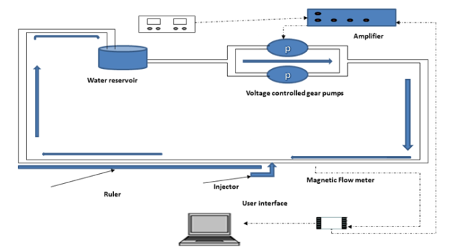
Experimental setup:
The system included tubes leading water in a closed circuit to and from a 4 liter reservoir of water using an up to 2.5 volt water pumps and the pipes in the area of interest were 3mm in diameter. The real fluid flow was calculated by measuring the time it takes a bubble of injected air to pass a distance of 20 cm. Four types of injections were used in pulsate and non-pulsate experiments differing in the volume and duration of injection.

Results:
- Estimated measurement error: 0.25s, 0.04cm
- Velocities and flow rates were calculated from using the following equation: Q=V*A. Q=flow rate, A=area of the tube, V=V_messured.
- The predicted velocity was calculated by calculating the predicted flow rate (Q), Q_predicted=Q_seringe+Q_fluid, and then extracting the predicted velocity using the equation Q=V*A

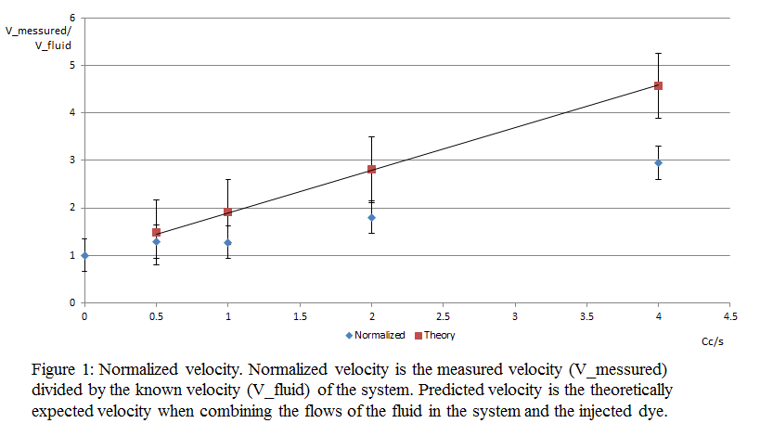
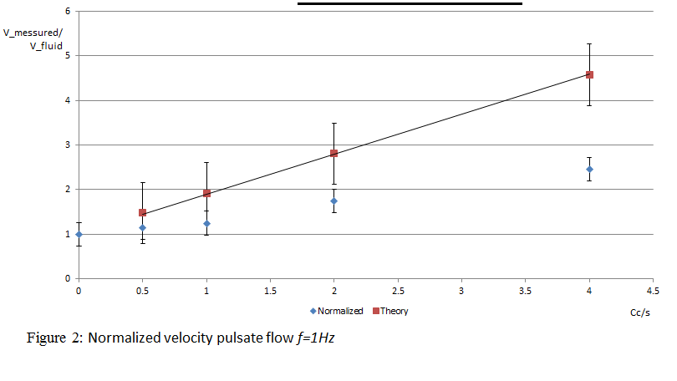
Non Pulsate flow: Pulsate flow:

Phase II – Clinical trial
Phase II will consist of measurements in the coronary artery.
A clinical trial has recently confirmed by the Helsinki Committee.
The study will include 15 patients, women and men, aged 18-80 who were referred for coronary heart catheterization and have intermediate lesion, which needs further clarification.
The clinical trial includes invasive measurement of flow, pressure and FFR index which will compare to our non-invasive measurement.
For this purpose we request an extension of one year of the study period.

