Fluid-Structure-Interaction Simulations of Aortic Valve Sparing procedures
Moshe Rosenfeld, Rami Haj-Ali and Ehud Raanan
Clinical experience with aortic valve repair indicates the need to normalize or reduce the diameter of the aortic annulus (AA). However, there are no guidelines based on solid-research evident to what extent the annular diameter (d_{AA}) is to be reduced to produce maximal coaptation and minimal stress on the leaflets. The objective of this study is to determine the influence of the valve configuration in general, and d_{AA} in particular, on the dynamics and durability of the aortic valve.
A fluid-structure interaction numerical model of the aortic valve with compliant root and leaflets was developed for the closing phase. Figure 1 shows a sequence of the closing phase. Six cases of aortic roots with d_{AA} between 20 and 30 mm were investigated. It was found that increasing the d_{AA} from 20 to 30 mm decreases the averaged coaptation height from 3.3 to 0.3 mm, respectively, as shown in Figure 2. The cases with 22≤ d_{AA} ≤26mm had stress lower than the minimum level of tissue stiffening, but the case of 24mm has the best optimal stress, strain energy and coaptation combination.
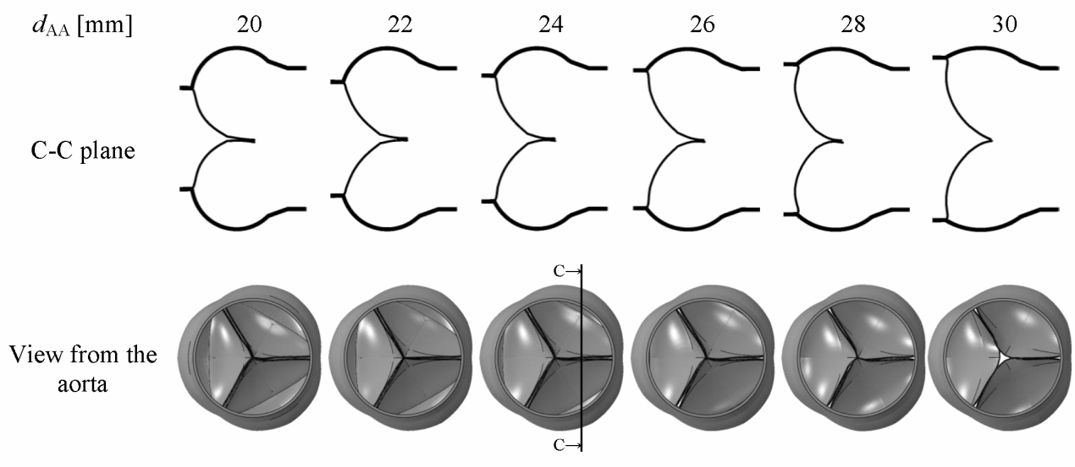Fig. 1: A sequence of the valve closing with coaptation
Fig. 2: Average coaptation height as a function of the d_{AA}

