Laser soldering of tissues using laser heating, improving the control system
Progress Report to the Slezak Center, December 2011
Submitted by Prof. Abraham Katzir
Introduction: The Applied Physics Group has been working for years on the development of temperature controlled laser bonding system, which will be used for the anastomosis of blood vessels. The idea is to approximate the ends of a bleed vessel, heat a spot on the incision to T=60C for t sec. till bonding occurs, and then move to a neighboring spot. We have obtained excellent results with t=10sec. but have not yet been able to determine the exact “end point” of the process. In other words we did not have some indication that after heating the spot to time t the incision under the heated spot was strongly bonded. There is a need to provide some method that will tell the surgeon that he/she can move the laser beam to a neighboring spot.
Hypothesis: In 2010 we suggested that Fiber-optic Evanescent Wave Spectroscopy (FEWS) can be used monitor changes of the infrared absorption of the bonded area. We hypothesized that a measurable change will appear in the spectrum when the approximated edges are strongly bonded.
Experiments: Testing the idea on small blood vessels is difficult, because one has to accurately heat a spot of diameter smaller than 1mm. We therefore decided to take the most sensitive tissue that was available to us: cornea, and test the idea on a thin slice of a cornea. We placed the cornea on a flattened fiber made of AgClBr and on top of the flattened part we placed the slice of cornea. This made it possible to measure the absorption of a small area on the cornea. We used the standard laser bonding system. It consisted of 3 parts: (i) A CO₂ laser whose energy, transmitted through one AgClBr fiber, heated a spot, (ii) An IR radiometer, connected to a second IR fiber, measured the temperature of the heated spot, (iii) PC controlled the temperature.
.
CO₂ laser
IR radiometer
PC control
Cornea
IR in from FTIR
IR out to FTIR
IR fiber
Flattened AgClBr fiber
Fig. 1 A schematic drawing of the experimental setup
Results: In the experiments, we heated a spot on the cornea, using different power levels of the CO₂ laser and for each power level we measured the absorption spectrum. Originally we also measured the actual temperature in each experiment, but we recently found an error in the calibration and we will have to do the time consuming calibration again. Figure 2 shows the changes in the measured spectra, at different laser power levels.

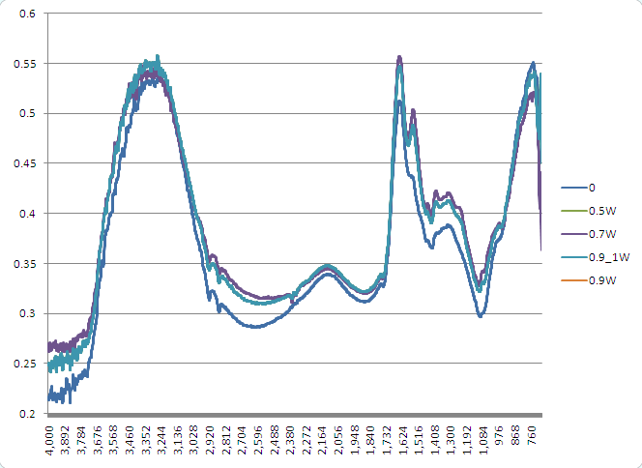

Fig. 2 The absorption spectra obtained after heating cornea at different power levels.
Conclusions: We concluded that from the graphs that the absorption spectrum is unique for each power level (which represents a different temperature). Each power level also yielded different bonding strength and therefore the next step is to find the laser power (or set temperature) that gives the strongest bonding. It is expected that at this point the approximated tissues are well bonded.
It seems that monitoring the changes in the tissue spectrum is likely to give us a good indication when we should stop the process (as we had hypothesized). This could be used as the method for determining the “end point” of the laser bonding process.
Future Work: In few preliminary experiments we have already replaced the slices of cornea with thin slices of blood vessels. We will have to confirm now that blood vessel walls behave in a similar fashion to cornea. We will then apply the above mentioned method for the anastomosis of blood vessels and see if indeed the FEWS method will give a good indication for the “end point.”

