Drug-Polymer Interactions as Vehicle for Controlling Release Profile of Antiproliferative Agents from Drug Eluting Stent

Prof. Meital Zilberman, Biomedical Engineering, Faculty of Engineering

Prof. Yoel Kloog, Neurobiochemistry, Faculty of Life Sciences

Tel-Aviv University

Summary of Research Activities
Drug-eluting stents significantly reduce the incidence of in-stent restenosis, which was once considered a major adverse outcome of percutanous coronary stent implantation. Localized release of antiproliferative drugs interferes with the pathological proliferation of vascular smooth muscle cells which is the main cause of in-stent restenosis. However, current metal drug eluting stents are associated with incomplete healing and lack of endothelial coverage.
Paclitaxel is a potent inhibitor of cell proliferation therefore is known to be very effective in the treatment of cancer as well as neointimal hyperplasia, which is known as the main cause of restenosis. Farnesylthiosalicylate (FTS, Salirasib) is a new rather specific nontoxic drug which was recently developed at the Tel-Aviv University. Both paclitaxel and FTS are relatively hydrophobic and are naturally slow released from polymeric structures.
In our study highly porous biodegradable stent coatings were developed and studied. The antiproliferative drugs paclitaxel and FTS were incorporated in these coatings, for controlled release to the blood vessel wall. The high coating porosity enables to release these hydrophobic drugs in a controlled desired manner. Part of our study focused on the polymer-drug interaction and their effect on drug release profile. In this regard the solubility parameter values of both drugs were calculated by Dr. David Alperstein (Ort Braude College, Israel) using Discover simulation software. The cohesive energy values of the drug/ polymer complexes obtained were lower than those of the pure polymers indicating a significant interaction between the drugs and the polymers. The solubility parameters of FTS and paclitaxel loaded in 75/25 and 50/50 PDLGA were found to have a similar value. The chemical structures of FTS, paclitaxel, PLA and PGA monomers were studied. The paired interaction function was used to calculate the suspected bonds of interactions between the drugs and the polymer's constituents. The carbonyl double bond of the polymer was found to have the strongest interaction with the hydroxyl bond of the drug. The calculated Van der Waals volume and area of paclitaxel presents a low area to volume ratio compared to that of FTS indicating that paclitaxel has a spherical molecular shape, whereas FTS has a straight linear shape. We therefore concluded that although the studied coatings were highly porous, the drug release profile from them is affected by the drug-host polymer interactions. The size and shape of the drug molecules also strongly affect their release profile from the studied polymeric structures

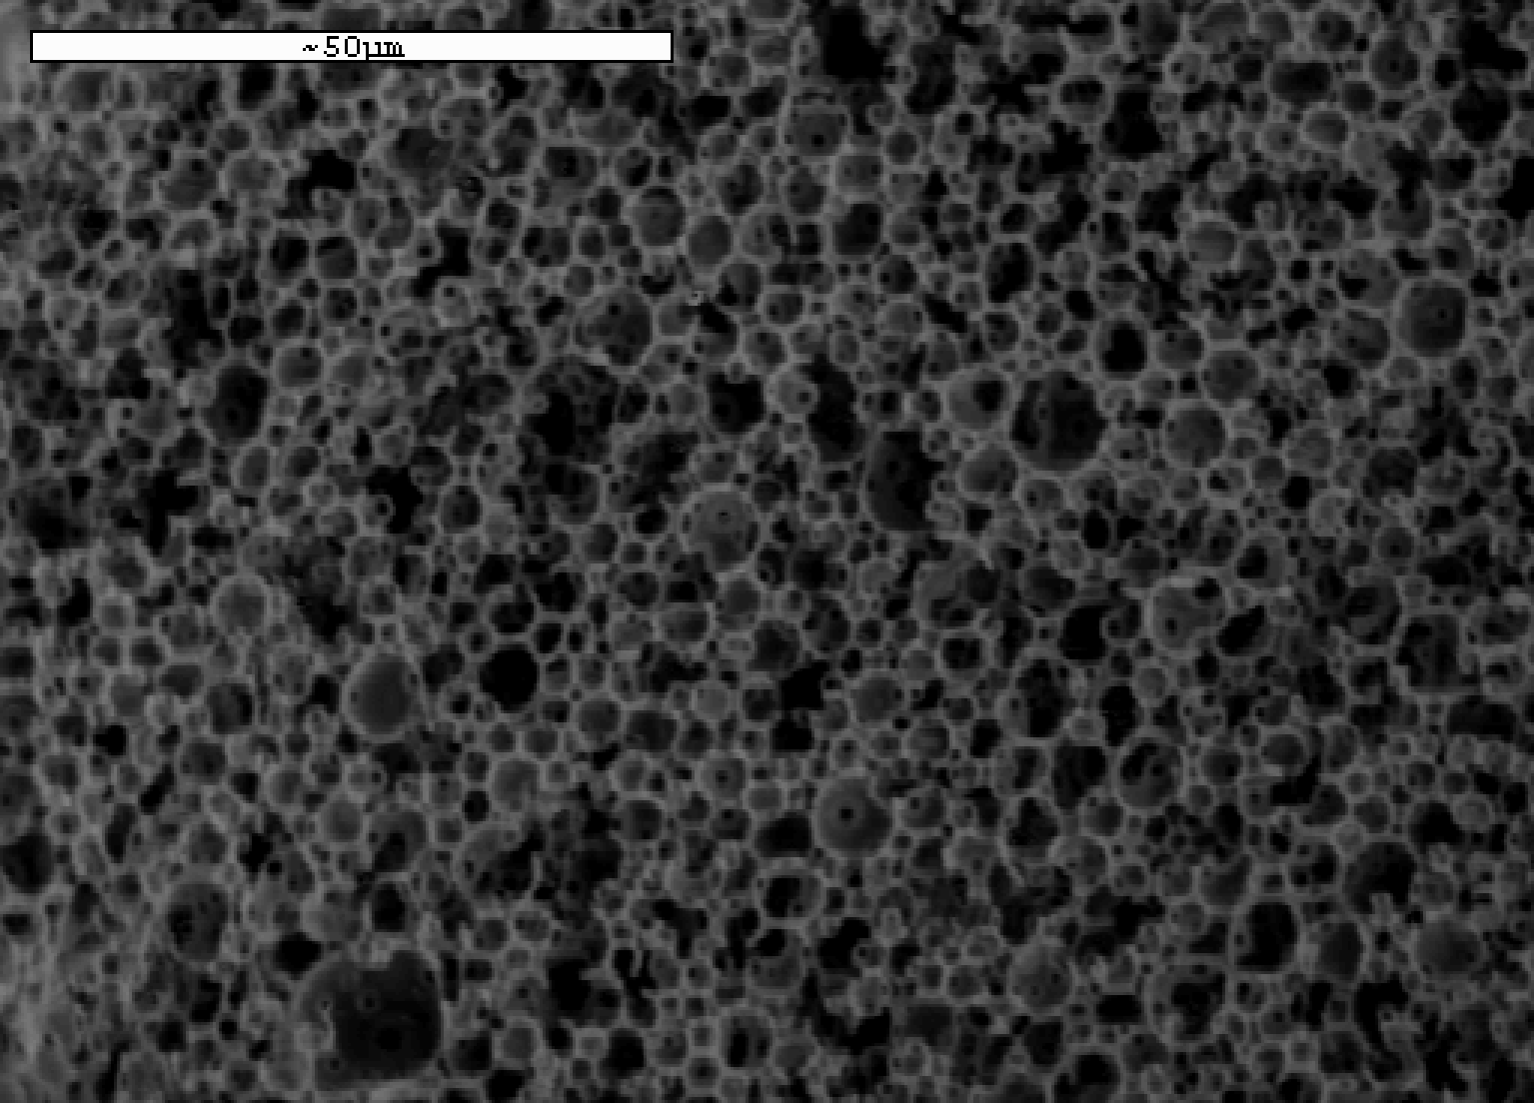
Fig. 1:
The drug-eluting highly porous stent coatings

